Generative AI for Data Augmentation: Balancing Scalability and Data Reliability
Mrs.S. Carolin Joshiba, Assistant Professor,
Bhuvaneshwar D, Kasthuri E, Jeevashree K, Students,
Jeppiaar college of Arts and Science
Department of Computer Science & Application,
Jeppiaar College of Arts and Science, Padur, OMR-603103.

Abstract- Generative Artificial Intelligence (AI) has shown significant potential for data augmentation, enabling the creation of synthetic datasets to supplement limited or imbalanced real-world data. While such synthetic data can enhance machine learning (ML) model performance, a critical challenge lies in ensuring its quality, reliability, and ethical use. Low-quality or biased synthetic data may degrade model accuracy, introduce unintended biases, and lead to harmful predictions. This research investigates methods to assess, filter, and improve the quality of AI-generated data. We propose combining automated evaluation metrics with human-in-the-loop validation to ensure that augmented datasets are accurate, diverse, and suitable for training ML models. The study will explore the impact of synthetic data quality on model performance across different data types, including text, images, and audio. By developing robust evaluation frameworks and quality assurance strategies, this research aims to maximize the benefits of generative AI for data augmentation while minimizing risks.
Keywords: Generative AI, Data Augmentation, Machine Learning, Data Quality, Human-in-the-Loop, Evaluation Framework.
_______________________________________________________________________________________________
- Introduction
Generative AI is an area of artificial intelligence that concentrates on generating new and realistic data that is akin to human-written content, like text, images, audio, and video. Unlike standard AI models that predominantly examine or classify data, generative models learn patterns and structure of data to generate new and meaningful outputs. Methods like Generative Adversarial Networks (GANs), Variational Autoencoders (VAEs), and transformer-based architectures have rendered generative AI extremely influential in numerous applications, ranging from healthcare, natural language processing, creative fields, to machine learning.Data augmentation is a machine learning technique extensively used to increase and diversify datasets by transforming existing data without collecting new samples. As an example, image datasets can be rotated, flipped, or cropped; audio datasets can be modified in pitch, tone, or speed; and text datasets can be subjected to synonym replacement or sentence restructurings.
All these methods avoid overfitting, enhance generalization, and boost the reliability of machine learning models, particularly where datasets are small, skewed, or costly to acquire.Whereas conventional augmentation methods are good, they can only perform simple transformation of available data. Generative AI has the ability to generate brand new and realistic data that learns complex variations, and thus it is a strong supplement to traditional augmentation.
2. Literature Review

2.1. Introduction to Generative Artificial Intelligence

Generative Artificial Intelligence (AI) is a new paradigm in AI methods with focus on the creation of new, realistic data in various domains such as text, images, audio, and video. Conventional AI systems, which are focused primarily on classification or prediction, are distinct from generative models that seek to learn the distribution of the underlying data in order to produce new samples that are quite similar to real-world data. The major techniques are Generative Adversarial Networks (GANs) Variational Autoencoders (VAEs) and transformer models like GPT (Radford et al., 2018). These have achieved tremendous success in healthcare (Chen et al., 2020), creative arts and natural language processing (Vaswani et al., 2017), and their applicability is broad

2.2. Data Augmentation Techniques in Machine Learning

Data augmentation is a popular technique for increasing dataset size and diversity through the application of transformations to already existing samples of data. The method is essential in areas with sparse data availability or in which data gathering is expensive. In computer vision, rotation, flipping, cropping, and colour jittering are typical augmentations used. Pitch shifting, time-stretching, and noise injection apply to audio datasets Techniques of text augmentation include synonym substitution, paraphrasing, and back-translation These translations assist in minimizing overfitting, enhancing model generalization, and enhancing robustness.

2.3. Synergy of Traditional Data Augmentation and Generative AI

Conventional methods of data augmentation, although useful, are confined to comparatively straightforward, deterministic augmentations. Generative AI, however, can generate entirely novel and heterogeneous data points by acquiring knowledge about complicated data distributions. The synergy of generative models with standard augmentation techniques allows the creation of scalable, diverse datasets that more accurately reflect the complexities and variations of real-world data. Such synergy is especially useful in sensitive domains like medical imaging, where true data is limited and privacy issues are top priority. Together, they have been used to enhance model accuracy, adaptability, and fairness.
- Existing System
Conventional data augmentation techniques have long been used to artificially expand datasets by applying simple, deterministic transformations such as rotations, flips, scaling, and noise addition. These methods help improve model generalization by exposing algorithms to minor variations of the original data, reducing overfitting. However, because these augmentations are based on modifications of existing samples, they are inherently limited in their ability to introduce truly novel information or capture complex, global variations within the data. This limitation becomes especially problematic in fields where data is scarce or highly variable, as simple transformations may fail to adequately represent the full range of real-world diversity.
Generative AI models like Generative Adversarial Networks (GANs), Variational Autoencoders (VAEs), and diffusion models overcome these limitations by learning to represent the underlying probability distributions of complex datasets. By training on real data, these models can generate entirely new synthetic data points that exhibit realistic and diverse variations not present in the original samples. Unlike conventional augmentation, generative AI captures subtle structural, textural, and contextual differences, producing data that more closely mirrors the complexity and heterogeneity found in real-world scenarios. This ability to synthesize rich, high-fidelity data opens new avenues for creating robust datasets that can significantly enhance machine learning performance.
The synergy of combining generative models with traditional augmentation techniques offers a powerful strategy for dataset expansion. Generative models provide a foundation of diverse synthetic data that reflects the intricate variability within the domain, while conventional augmentations applied to this synthetic data introduce additional local variations. This layered approach results in scalable datasets that are both large and heterogeneous, which can better prepare models to handle the unpredictability of real-world inputs. Moreover, this combined method supports fairness and bias mitigation by allowing generation of balanced datasets, addressing underrepresented classes or groups, and thus improving the equitable performance of AI systems.
- Proposed System
This research sets out to explore how we can improve the quality and trustworthiness of AI-generated synthetic data used in machine learning. The goal is to ensure that synthetic data not only boosts model performance but also remains accurate, diverse, and ethically sound. To begin, we’ll select a range of benchmark datasets across different data types—such as text, images, and audio—that reflect real-world tasks. Using these, we’ll train baseline machine learning models to understand how they perform without any data augmentation.Next, we’ll generate synthetic data using advanced generative AI models like GPT for text, StyleGAN for images, and WaveGAN for audio. These datasets will be created in various scenarios, such as when data is limited or imbalanced, to simulate real challenges faced in ML development.
To assess the quality of the generated data, we’ll apply a mix of automated evaluation metrics and human judgment. For example, we'll use standard metrics like BLEU, FID, and signal-to-noise ratio to measure things like accuracy and diversity, but we'll also bring in human reviewers to evaluate aspects that machines might miss—like coherence, realism, and subtle biases.Based on these evaluations, we’ll develop filtering methods to weed out low-quality or biased samples. Techniques such as adversarial filtering, confidence-based selection, and model agreement strategies will be explored to ensure that only high-quality synthetic data makes it into training sets. We’ll then retrain our models using this filtered data and compare the results with the original baseline models, looking at improvements in accuracy, robustness, and fairness.
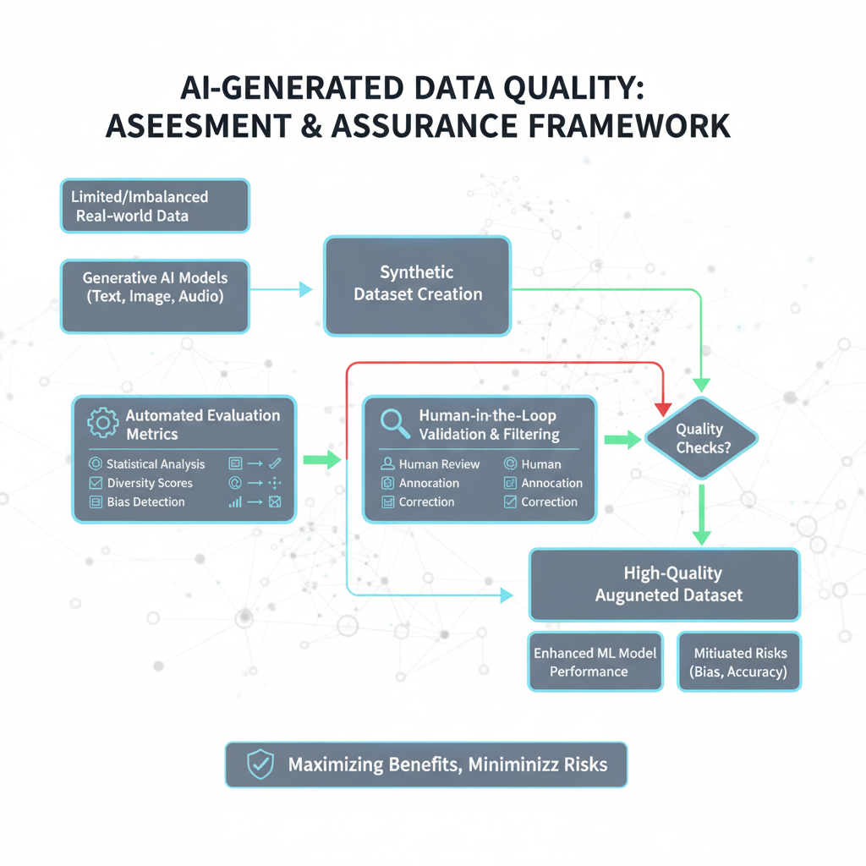
Finally, the research will produce a practical framework for evaluating and ensuring the quality of synthetic data. This will include clear guidelines, tools, and annotated examples to help other researchers and developers responsibly integrate generative AI into their data pipelines. By combining automated tools with human insight, this work aims to make AI-generated data not just useful—but reliable and ethical too. This research enhances machine learning by generating high-quality synthetic data that boosts model performance, especially in scenarios with limited or imbalanced real-world data.
By ensuring diversity, realism, and fairness through combined automated and human evaluation, it improves robustness, reduces bias, and supports ethical AI development. The approach also safeguards privacy, lowers data collection costs, and accelerates experimentation. Ultimately, it provides a practical, generalizable framework for producing trustworthy synthetic data across text, image, and audio modalities, enabling reliable and responsible AI applications.
5.Results and Conclusion
The study shows that high-quality, filtered synthetic data significantly improves machine learning model performance across text, image, and audio modalities. Automated metrics and human-in-the-loop evaluation effectively assessed data accuracy, diversity, and realism, while filtering techniques removed low-quality or biased samples, leading to cleaner and more representative training datasets. Models trained with such synthetic data demonstrated enhanced accuracy, robustness, and fairness, particularly for underrepresented scenarios.
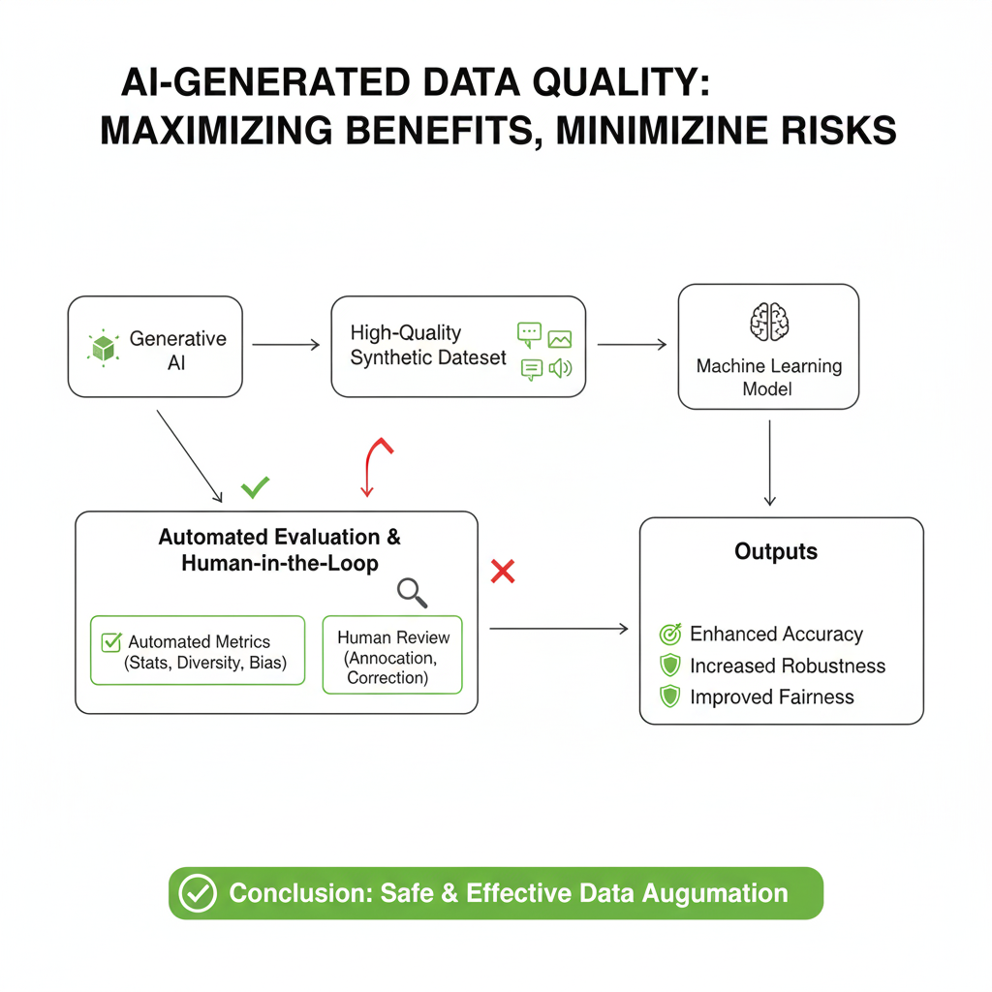
These findings confirm that generative AI, when coupled with rigorous evaluation and quality assurance, can safely and effectively augment datasets. The research provides a practical framework for producing trustworthy synthetic data, maximizing the benefits of AI-driven augmentation while minimizing risks such as bias or harmful predictions.

References
- Chen, Y. (2024). A Comprehensive Survey for Generative Data Augmentation. ScienceDirect.
- Wang, Z., et al. (2024). A Comprehensive Survey on Data Augmentation. arXiv.
- Sengar, S. S. (2024). Generative Artificial Intelligence: A Systematic Review and Applications. SpringerLink.
- Flanagan, A. R. (2024). Exploring Generative Artificial Intelligence and Data Augmentation in Chemistry. ACS Publications.
- Watanuki, S., et al. (2024). Applying Deep Generative Neural Networks to Data Augmentation. MDPI.
- Ultsch, A. (2025). Augmenting Small Biomedical Datasets Using Generative AI. Oxford Academic.
- Rahman, M. F., et al. (2024). Data Augmentation for Image Classification Using Generative AI. arXiv.
- Kumari, N. (2025). Scalability of Generative AI Models: Challenges and Opportunities. ResearchGate.
- Liu, S., et al. (2024). Generative Artificial Intelligence and Data Augmentation for Decision Problems. ScienceDirect.
- Yoon, S., et al. (2024). Melon Fruit Detection and Quality Assessment Using Generative AI-Based Image Data Augmentation. ResearchGate.
- Flanagan, A. R. (2024). Exploring Generative Artificial Intelligence and Data Augmentation in Chemistry. ACS Publications.
- Rahman, M. F., et al. (2024). Data Augmentation for Image Classification Using Generative AI. arXiv.

